HOW DOES ACUPUNCTURE WORK? A LOOK AT SOME MECHANISMS
The mechanisms underlying how acupuncture relieves pain have been extensively researched for over 60 years. Sensory nerve pathways involving specialized nerve fibers (Aδ, Aβ and C, to be precise) and descending nervous system pathways have been mapped. Numerous biochemicals have been identified including opioid and non-opioid neuropeptides, and neurotransmitters such as serotonin, norepinephrine, dopamine, cytokines, glutamate, nitric oxide, and gamma-amino-butyric-acid (GABA).
Acupuncture analgesia has been shown to involve several classes of naturally produced opioid neuropeptides including enkephalins, endorphins, dynorphins, endomorphins, and nociceptin (also known as Orphanin FQ). Among the non-opioid neuropeptides, substance P (SP), vasoactive intestinal peptide (VIP) and calcitonin gene-related peptide (CGRP), which plays a central role in the pathogenesis of migraine, have been investigated for their roles in both the analgesic and anti-inflammatory effects of acupuncture.^{3,13}
Many biochemical and signaling pathways have been identified as playing a direct role in how acupuncture achieves its clinical effects, but perhaps the most central pathway that acupuncture uses, one that helps explain how it is effective in such a diverse array of clinical areas, is that acupuncture has been demonstrated to directly initiate a process called purinergic signaling, a primitive¹⁴ and ubiquitous system in the body using adenosine and ATP for signaling and regulation in all tissues and organ systems.¹⁵ It is now understood that all nerve transmission requires ATP as a co-factor and the that the body uses purine levels as a primary background signal of both healthy function and tissue damage. Studies on mice demonstrate that those that were bred to be unable to bind to adenosine did not have pain relief from acupuncture nor any of the chemical changes associated with acupuncture pain relief, while the normal mice did^{16,17} and this effect was repeated in humans.¹⁸
Purinergic signaling has been demonstrated to play a central role in such diverse clinical areas as migraines and headaches,¹⁹ immune dysfunction and inflammation,²⁰ cancer,²¹ autism,²² Alzheimer’s,²³ cardiovascular disease,^{24,25} endocrine function,²⁶ embryological development,²⁷ and gastrointestinal disorders²⁸. While pharmaceutical companies are currently attempting to develop drugs in all of these areas to inhibit or enhance purinergic signaling,²⁹ safety is an issue as the balance of these compounds at the cellular level is delicate, and both too much and too little adenosine and ATP are associated with disease. However, stimulating improved self-regulation of purinergic signaling through acupuncture treatment is likely both effective and safe.
In addition to biochemical actions, studies also demonstrate direct effects of acupuncture on the central nervous system. These include spinal reflex effects, where acupuncture stimulates muscle relaxation and changes in visceral organs. In the brain, acupuncture has been shown to change functional connectivity, decreasing activity in limbic structures associated with stress and illness while improving the regulation of the hypothalamus-pituitary-adrenal axis, the primary system that the body uses for regulating hormones and the physiological stress response.³⁰ Additionally, acupuncture modulates parasympathetic activity, the branch of the nervous system associated with rest, relaxation, digestion and tissue healing.³¹
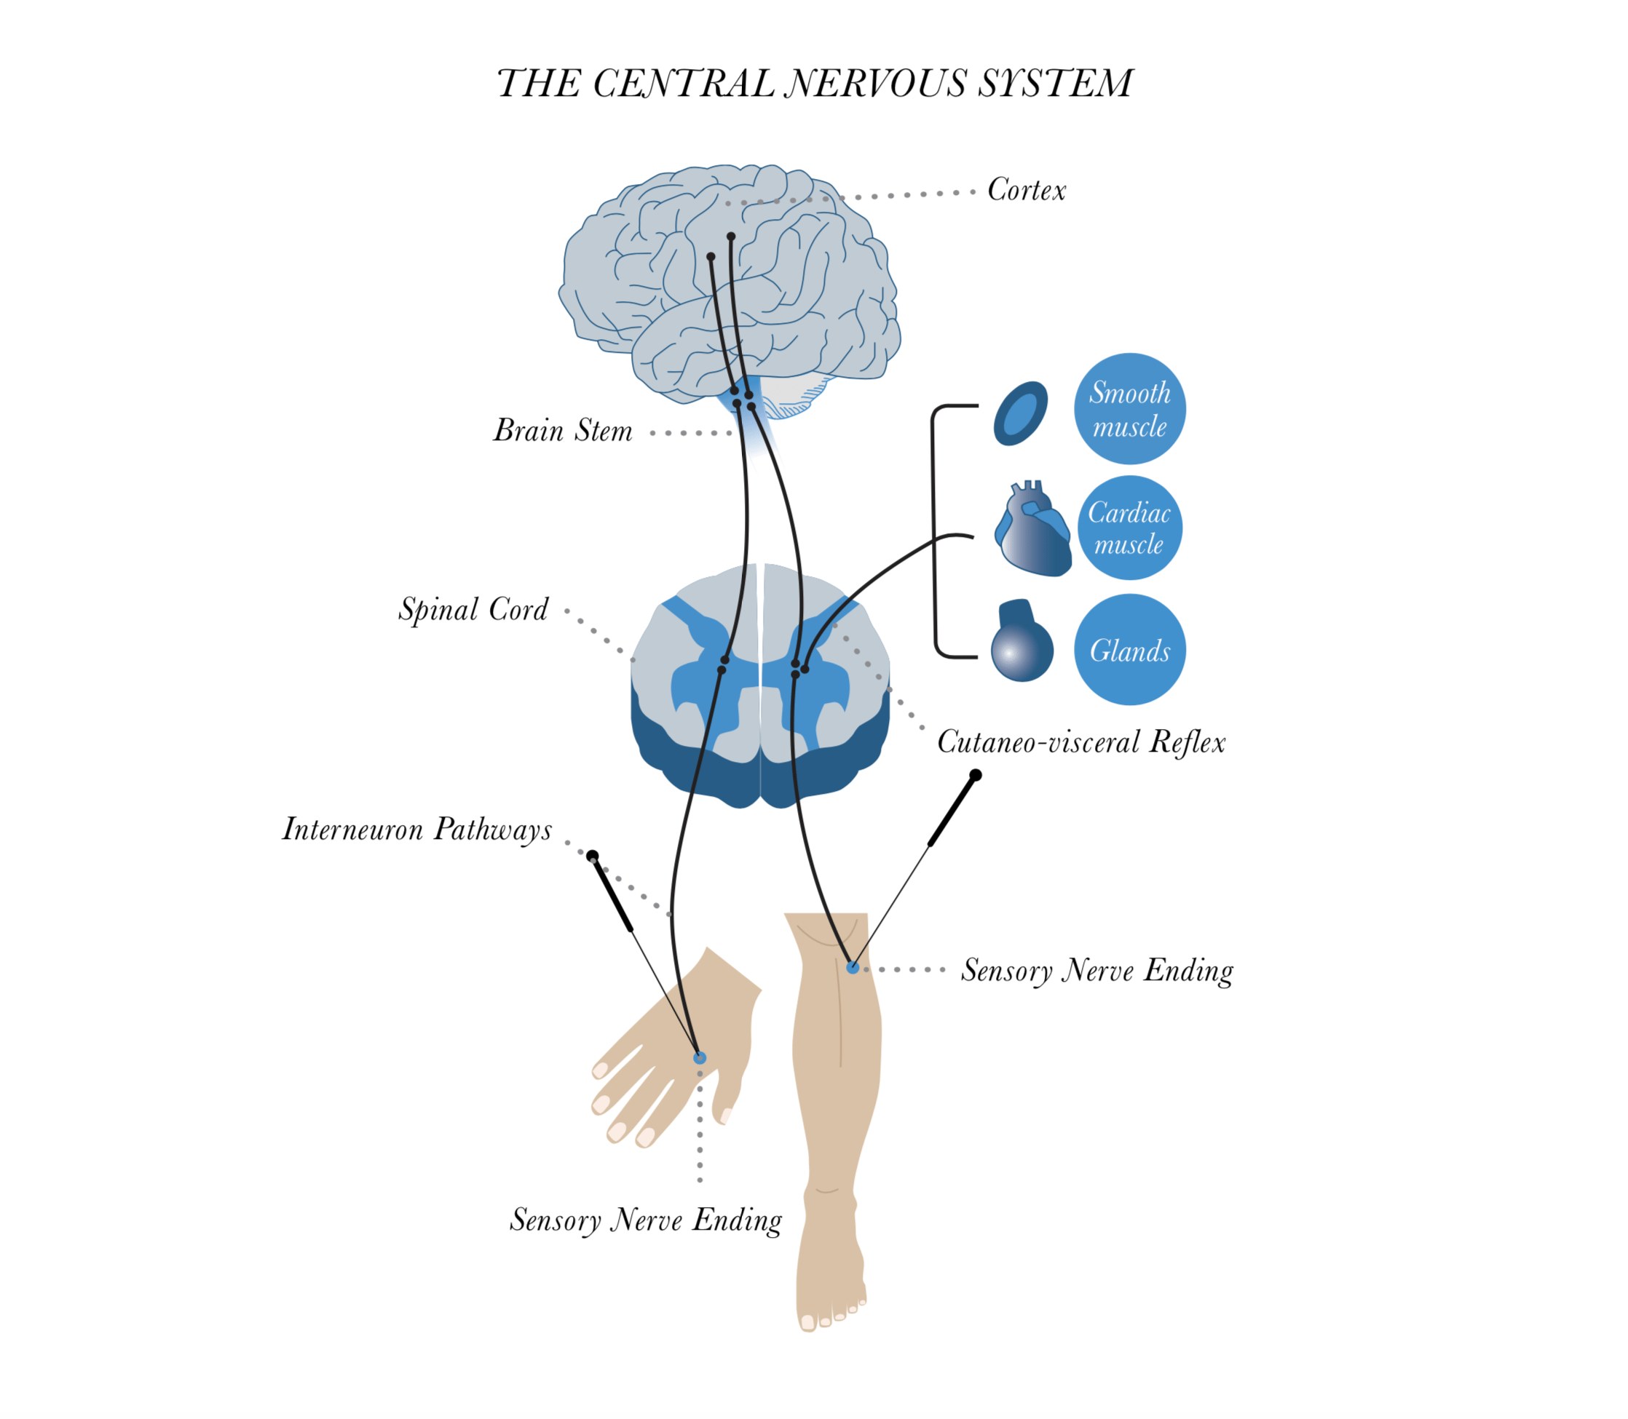
Kilde: Evidence Based Acupuncture

